Group Bay App for Android

1. Install GroupBay.apk

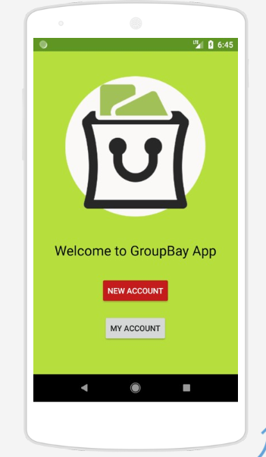

2.Create new account or use one of default accounts

USERS                          PASSWORDS

[user@gmail.com](mailto:user@gmail.com)              qwerty

[user2@gmail.com](mailto:user2@gmail.com)            qwerty

[user3@gmail.com](mailto:user3@gmail.com)            qwerty

[user4@gmail.com](mailto:user4@gmail.com)            qwerty

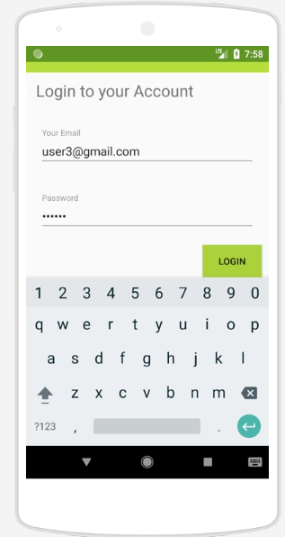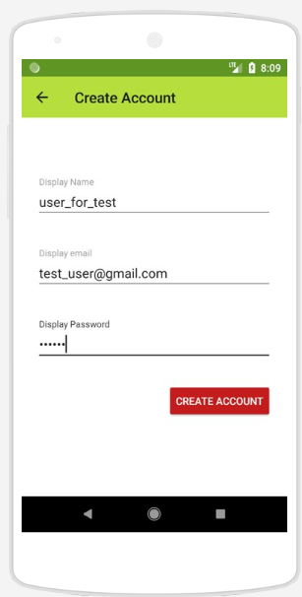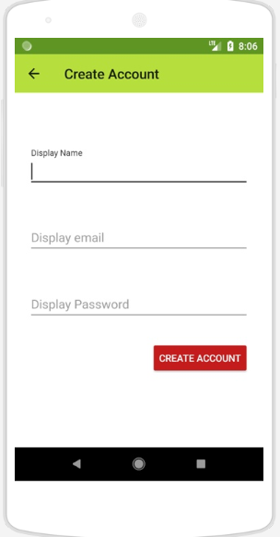

3. Talk with your friends and find new

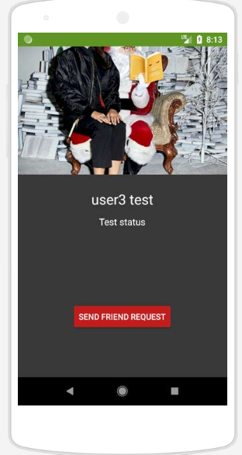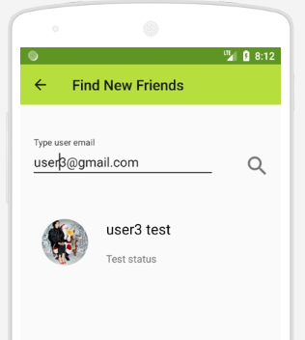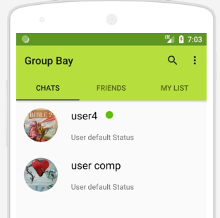

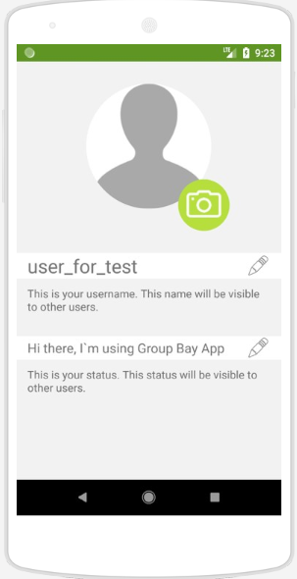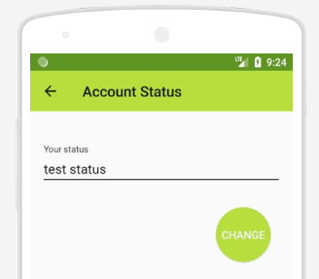4. Add your own profile picture , tell your friends how you feel today

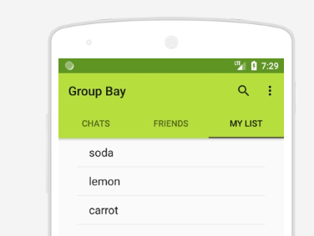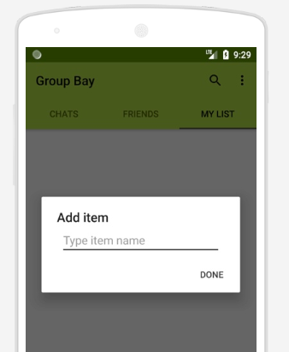5. Create your shopping list

This app was written as part of the Android course. All data is stored on firebase servers.